**Computational Intelligence  
R e d W i n e - Q u a l i t y**

**CHRISTIAN J H PAKPAHAN  
5025201153**

**Source Code**

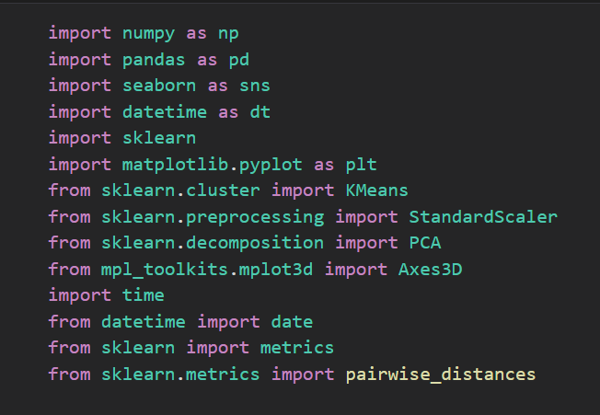

**Step 1 add the library and import the file (csv) into the code. After rhat,   
use function :**

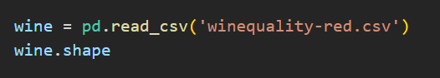

And print the data with function ‘print’. It will show the data that we imported from file csv

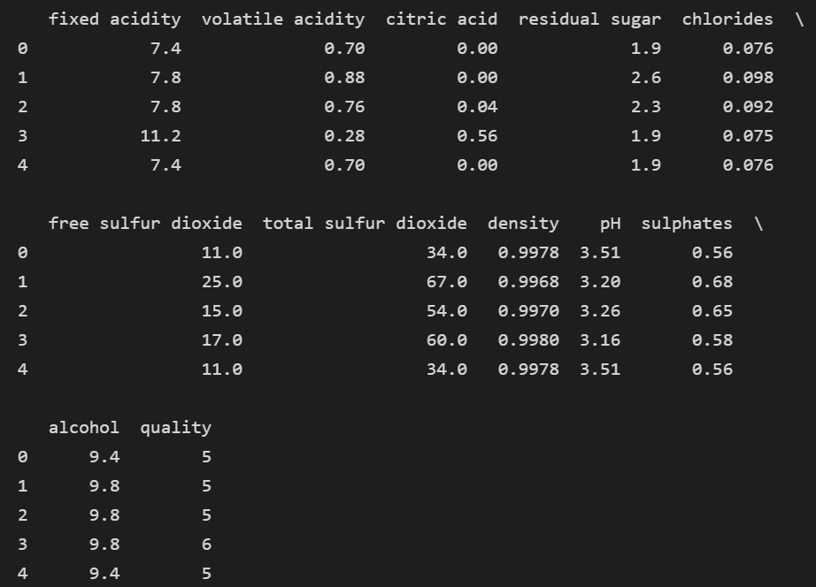

**Now , in this code we make chart pH and will be show the chart below.**

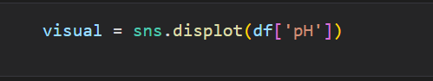

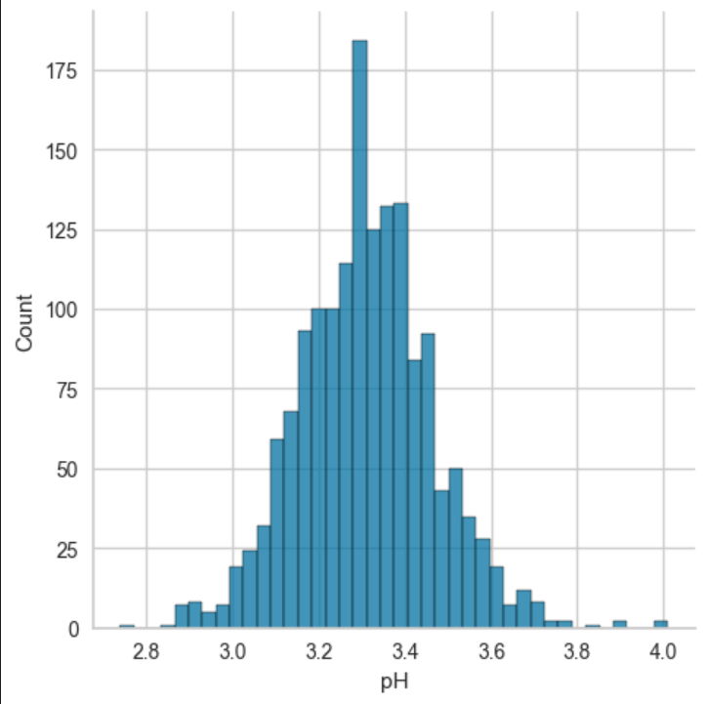

Make the Elbow methods and have inertia value with ‘wcss.append(kmeans.inertia_)’

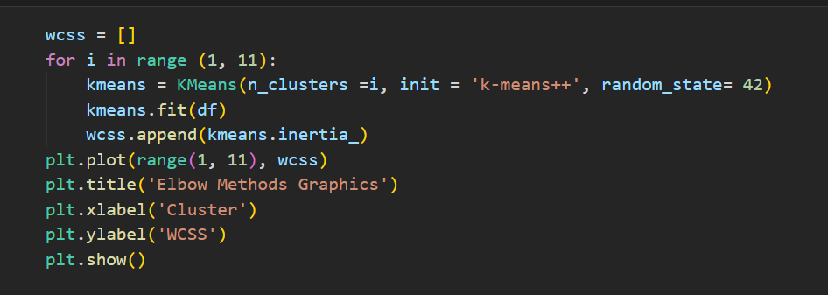

With the result :

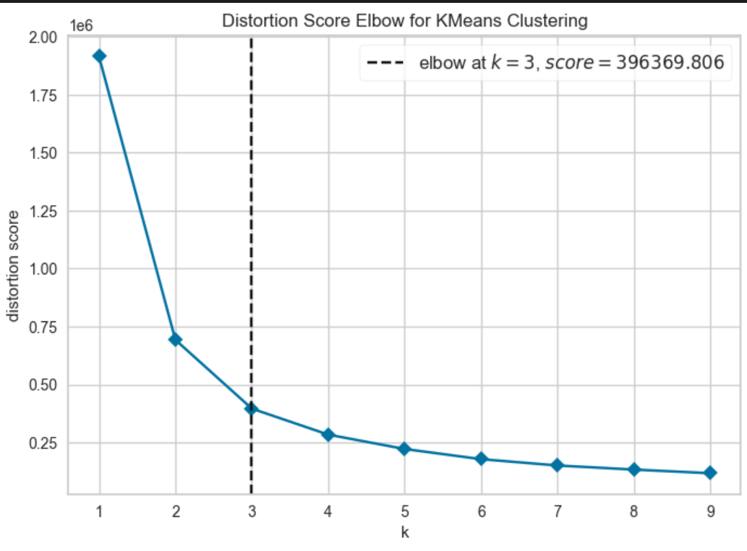

Take the Graphic to clustering dot value in label with size 20

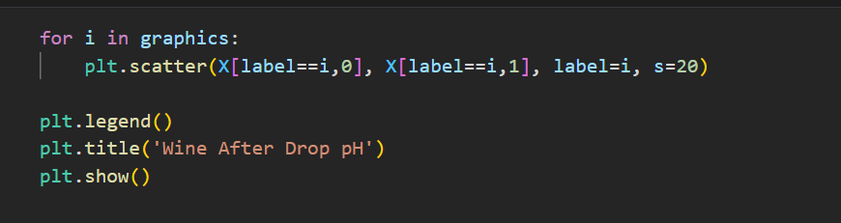

The result

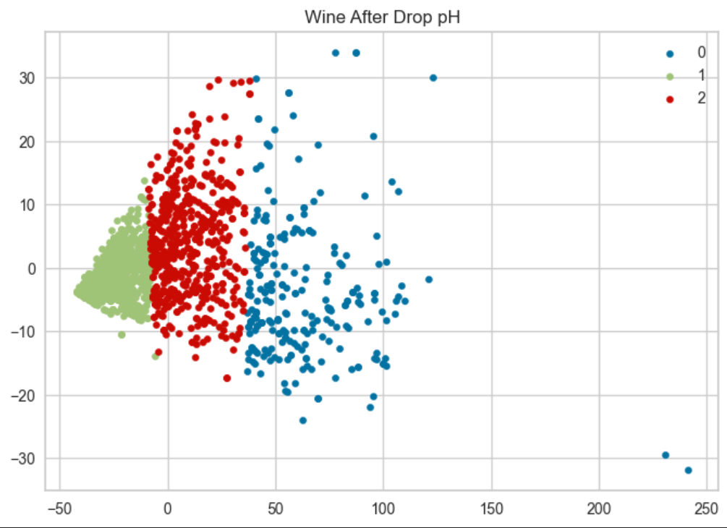

**And make this code to normalize data**

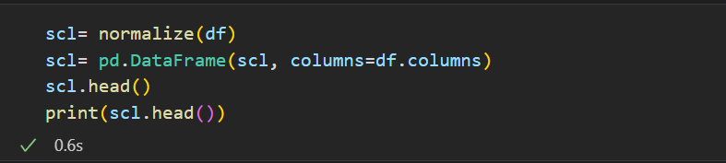

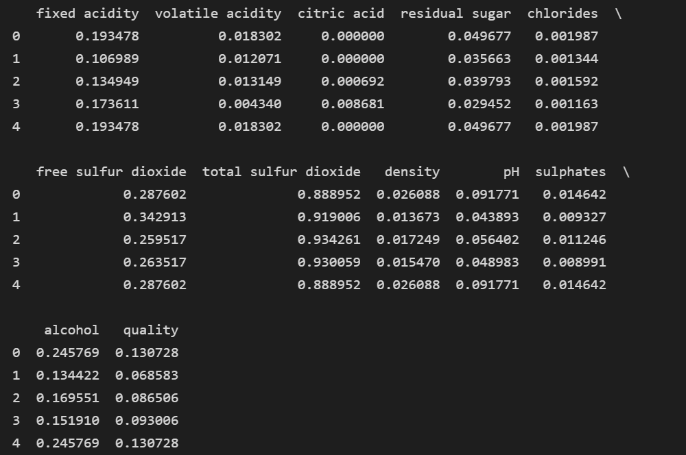

To cluster distance using average linkage

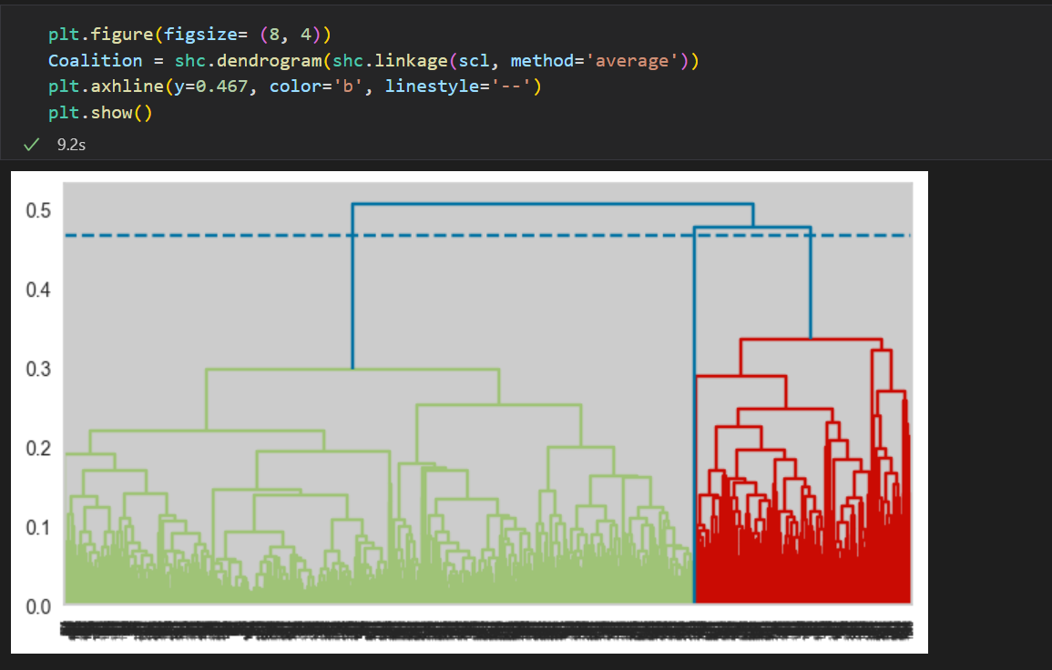

Cluster distance using this complete methode :

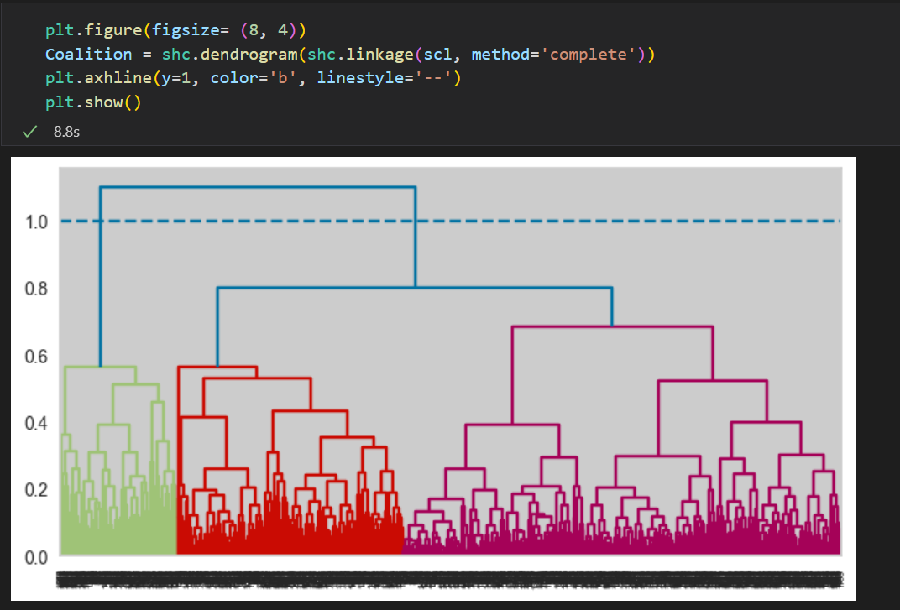

Cluster distance using this single methode :

